Farming Connect Management Exchange

Marc Harries

Ireland

Agrivoltaics

July 2022

Background

Our lowland holding of 300 acres is a medium sized family sheep farm. In order to keep our business viable in changing times and for the next generation, we are exploring options to develop our stock as well as farm diversifications. Our current farm diversifications include holiday lets, biomass boiler and solar PV. All of which are working well for us at present.
Having previously worked in solar PV for a short while over 25 years ago, I was interested in installing additional PV systems for the farm and for further diversification projects. My main concern was that we didn’t have additional suitable roof space for further PV solar and we didn’t want to lose useable land with a ground mounted system.
After some research I came across an interesting Agrivoltaic system from Germany company Next2Sun that was worth a closer look. The term Agrivoltaics is used for solar PV systems that allow for the joint use of land and agriculture.
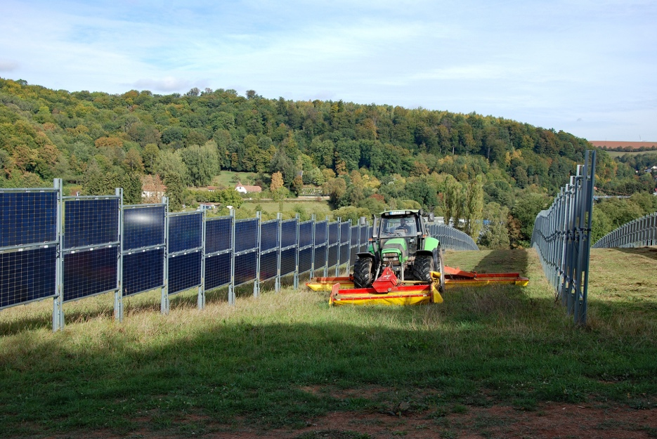

With the ever-increasing cost of electricity I was also interested in battery systems and how we could store any surplus energy we were producing – instead of selling back to the grid.

Itinerary

I had initially intended to travel to Bavaria in Germany to visit some large-scale utility size solar farms.
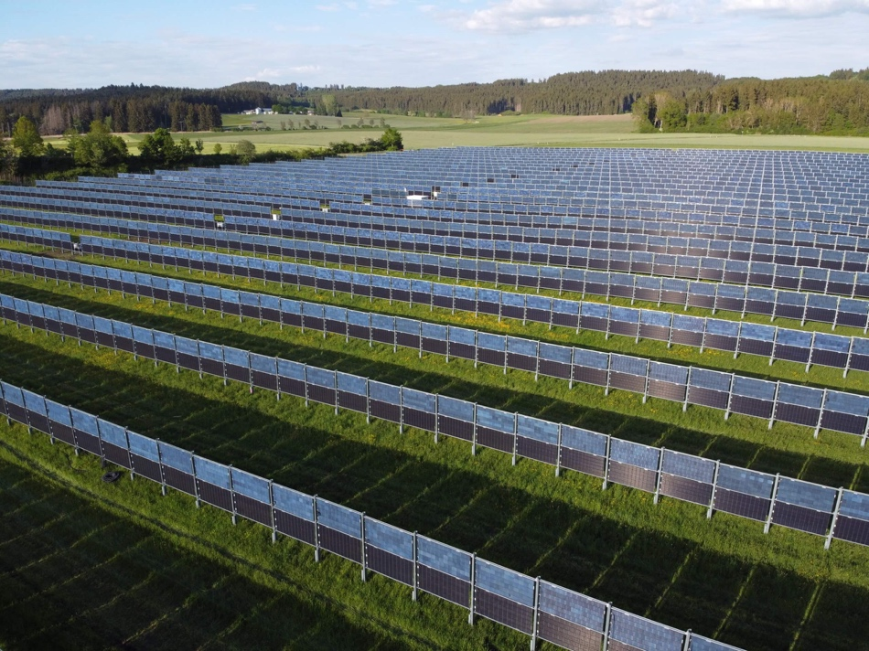

Large scale 5MWh/year bi-facial system in Baden-Württemberg, Germany

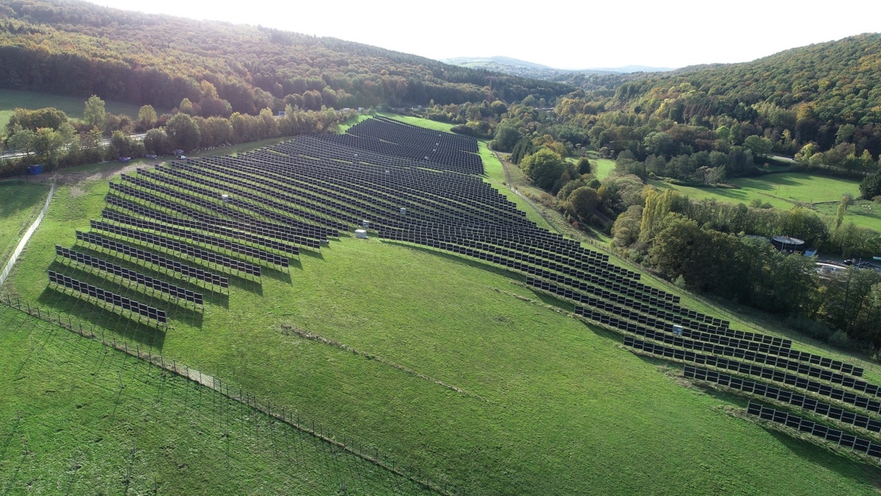

2MW system in Saarland Germany, site used for hay and silage crop

However, it became clear that some smaller scale, farm size installations might give a better example of a real-life system that would be suitable for our location and needs.
Luckily there were two systems installed near Waterford, Ireland.
Day 1.
I had arranged to meet Gene Hourihane of Sun Stream Energy who had installed the two systems I was going to visit. Gene founded his company in 2005 and specialises in agriculture and commercial PV installations up to 100KW.
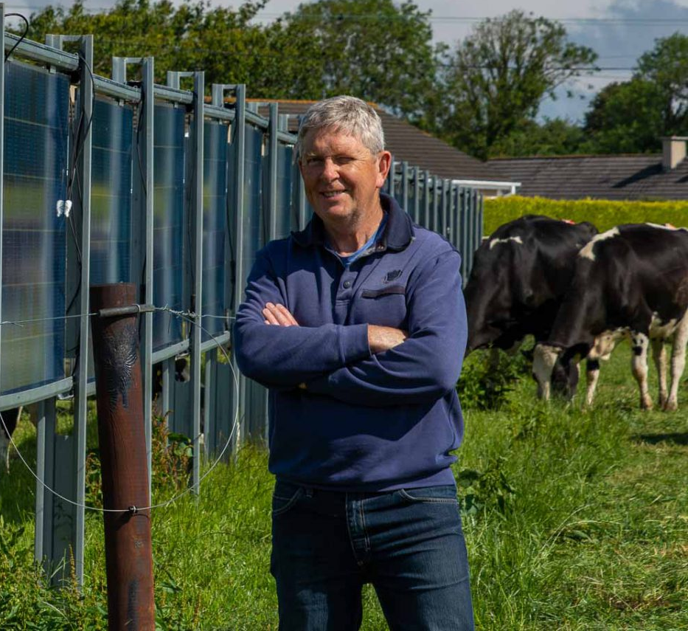
Gene is a qualified mechanical engineer with experience in engineering design, manufacturing, and management.

Gene explained the rationale behind the vertical bifacial panels.
The economic benefit of solar PV improves as more of its energy is consumed on-site. This is possible if the onsite base electric load (minimum load) is substantial and steady relative to the peak load and not less than peak solar power generation. Except for commercial–industrial applications, steady electric loads are not the norm. Dairy farms have high variations in electric loads, especially those batch milking cows in the morning and evening. Here the peak loads morning and evening are typically ten times greater than midday loads.
The conventional approach to Solar PV is to install modules on a south-facing roof to maximize the energy generated from the midday sun. But this approach is not ideal for the dairy farmer milking twice a day as peak solar power and peak farm electric loads occur at different times. Here a substantial amount of the solar energy is overspilled to the grid at little or no value.
I asked Gene, what were some of the main advantages of the bi facial system?

“They produce electricity by utilizing light shining on both sides of the panel. They face east and west leading to peak solar energy generation in the morning and evening – ideal for dairy farmers!”
“The support frame consists of galvanised steel mullions and crossbeams, the panels are a tempered glass – glass laminate. The whole structure is designed to withstand wind speeds up to 100mph+.”
“The energy production is equivalent to south facing roof mounted systems at pitch angles 0f 30-40˚ and up to 15% more than systems on roofs of 10-20˚ pitch angle.”
“Being vertical they use virtually no ground space, livestock can graze alongside and even under the panels.”

The first site visited was at the farm of Pat Farrell and his son Owen in Ballyhoo, Waterford.
Pat has a dairy herd of 240 cattle, milking twice daily. Pat’s energy consumption had risen to over 70,000Kwh per year so in 2019 he contracted Sun Stream Energy to install the system with the aim to be as energy self-sufficient as possible.
The location chosen was a field close to the yard that was unrestricted by trees to allow maximum sunight to be captured by the solar panels. Being close to the yard required less cabling therefore reducing installation costs.
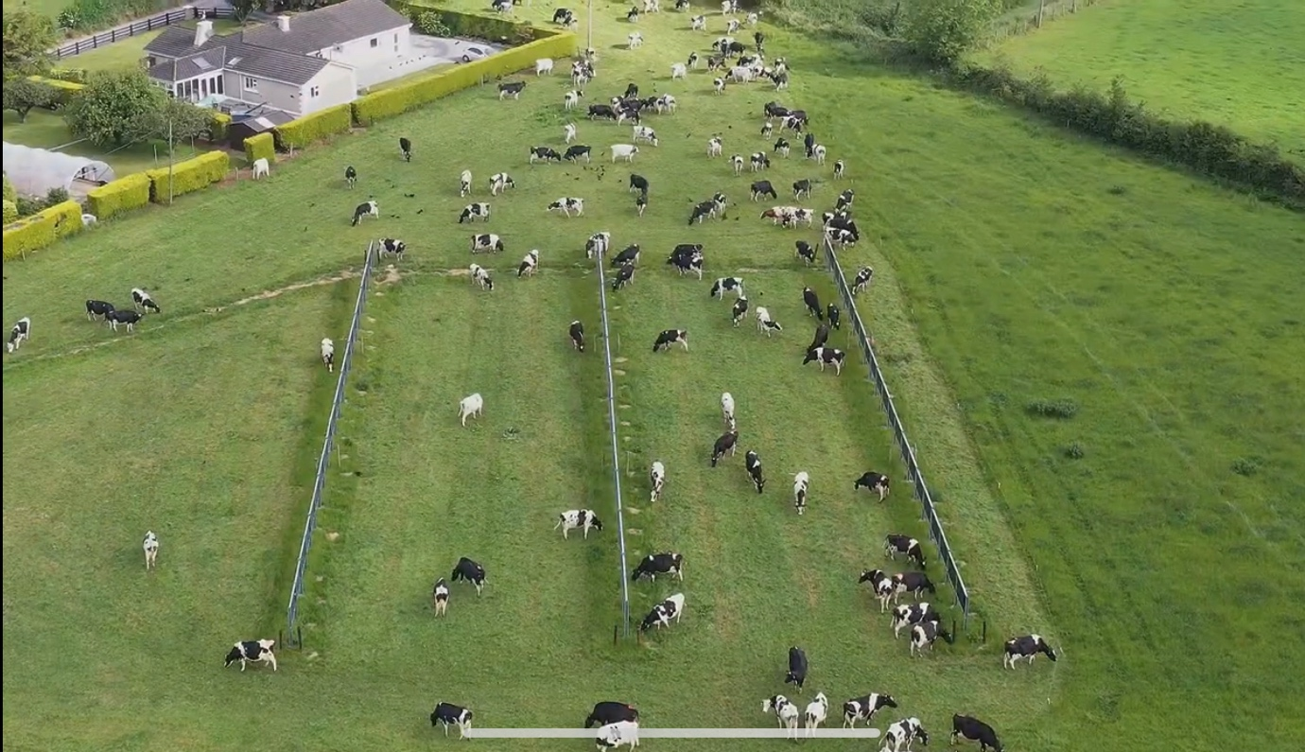
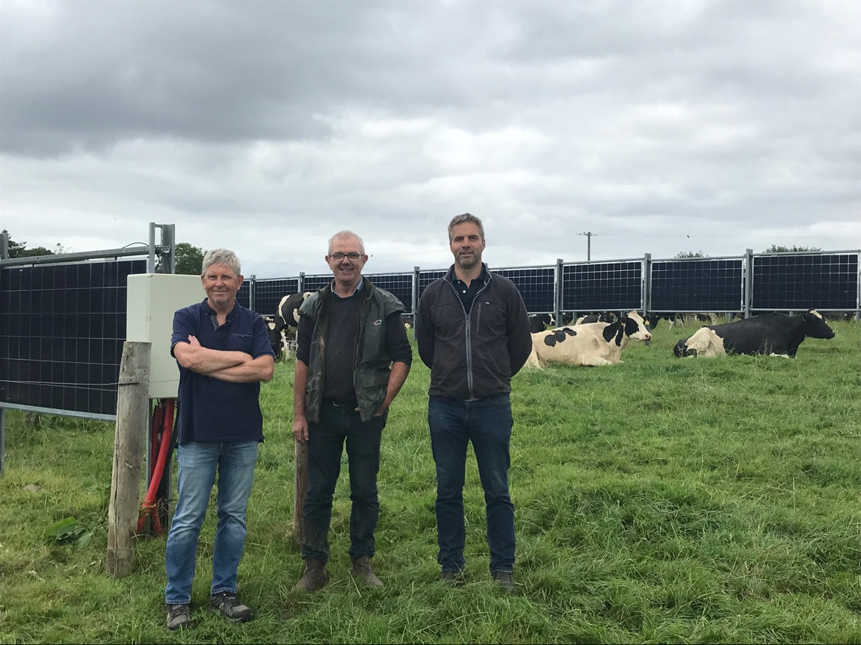
(L-R) Gene Hourihane, Pat Farrell and me.
The cattle are happy to graze amongst the panels, they are protected by an electric fence. Since their installation in 2019 there as been no damage to the panels or the cows!
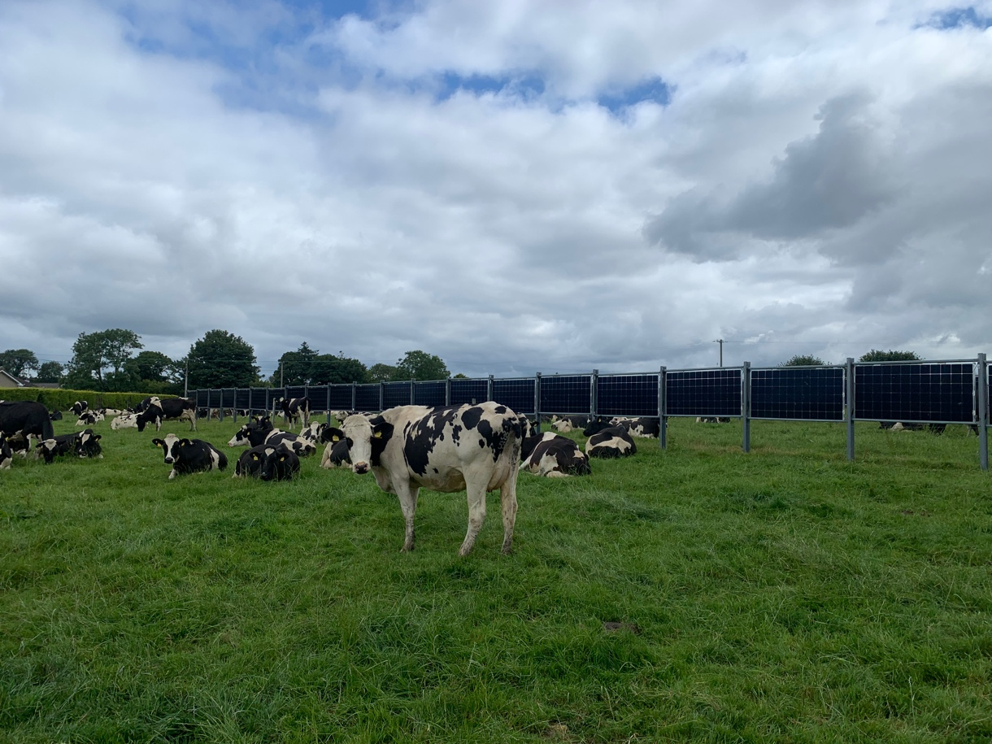
Cows and panels.
Minimal ground loss.
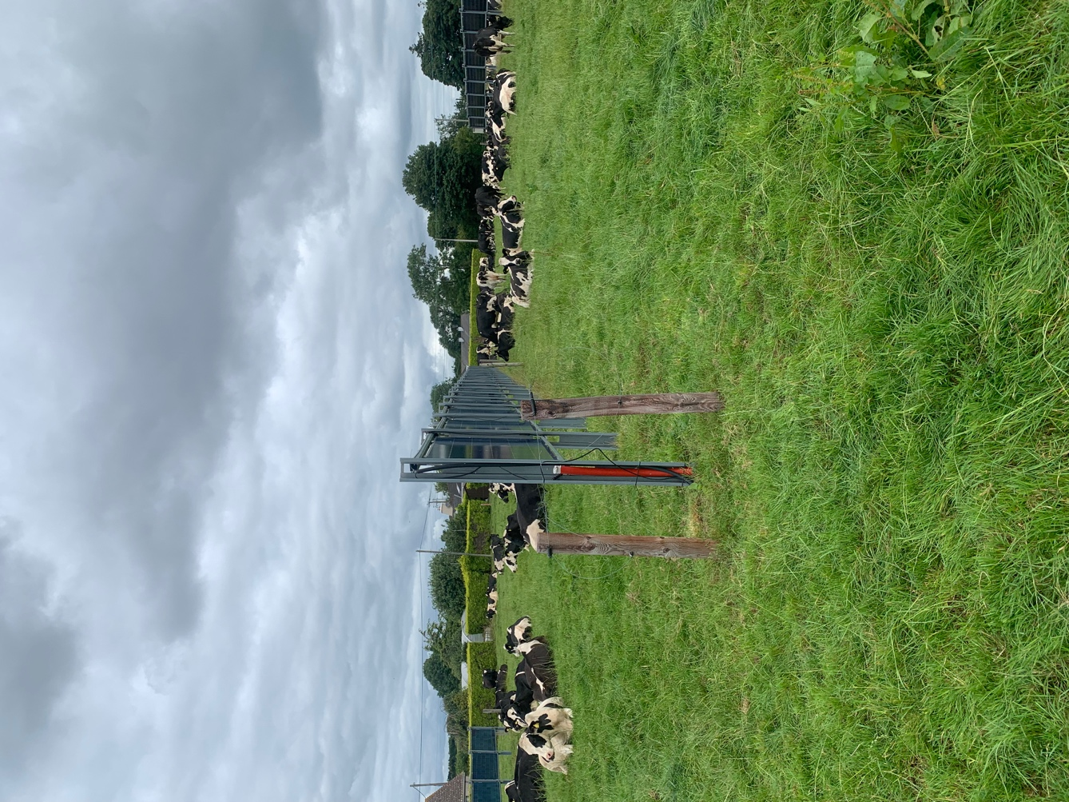
side on of panels.

Pat explained the main benefit to his business was reducing energy costs by 25% and being 23% self sufficient. This is achieved by using as much of the electricity produced themselves and minimising exports.
40% of energy used on farm goes on cooling the milk so this was an obvious please to make a saving. This site uses two forms of storage, batteries and ice!

Power management.
Where the electricity produced goes to is controlled by the smart inverter.

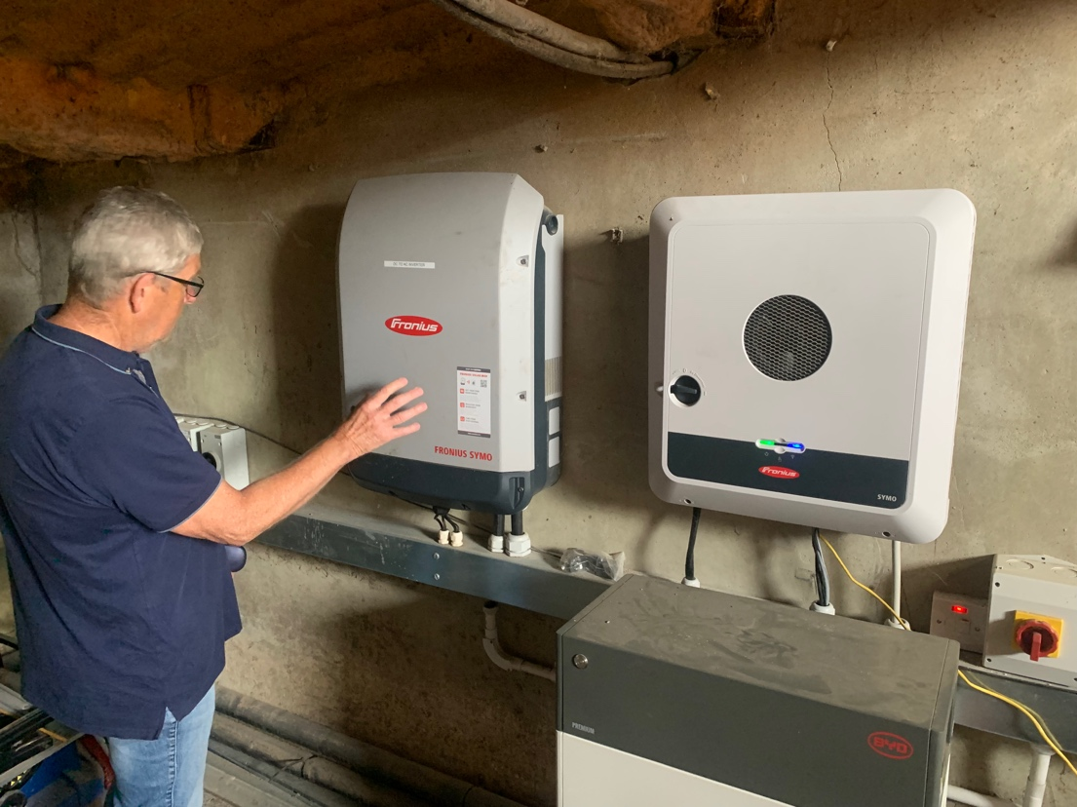
Inverter and control system
Any excess electricity produced is first diverted to the ice bank via the control system, this continues until the ice bank reaches a set volume of ice. Once this is reached any excess power is diverted to the battery storage system.
The Ice bank, manufactured by Kilkenny cooling, was installed in 2020 capable of holding 1280kg of ice has the capacity to store over 100kwh of energy. The milk is initially cooled to 20°C via water from a bore hole and then cooled using the ice bank via a heat exchanger to 3°C.
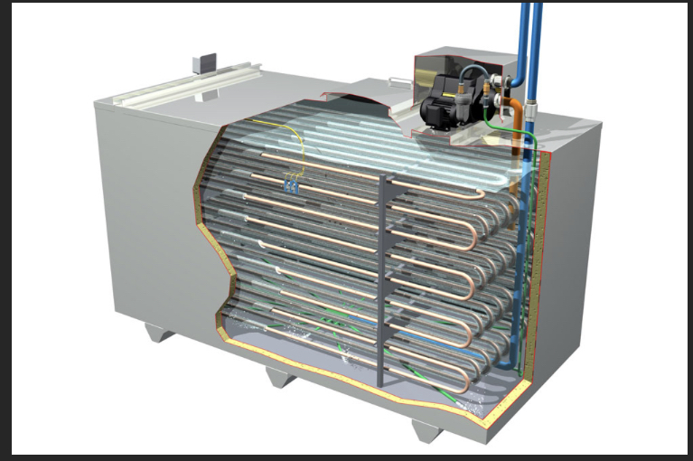 Cut away of ice bank.
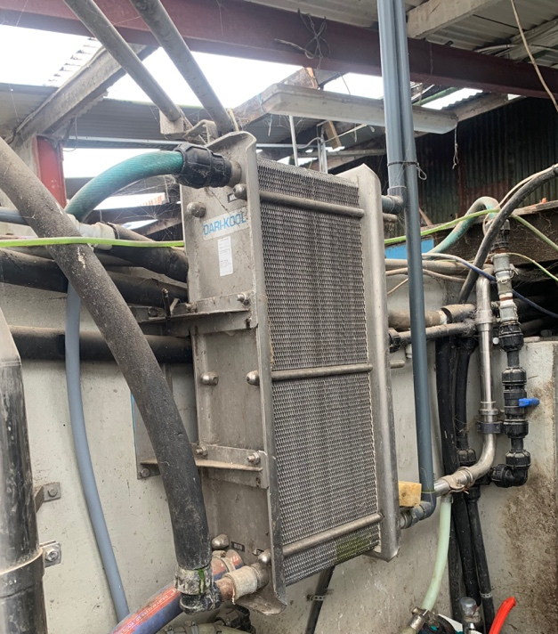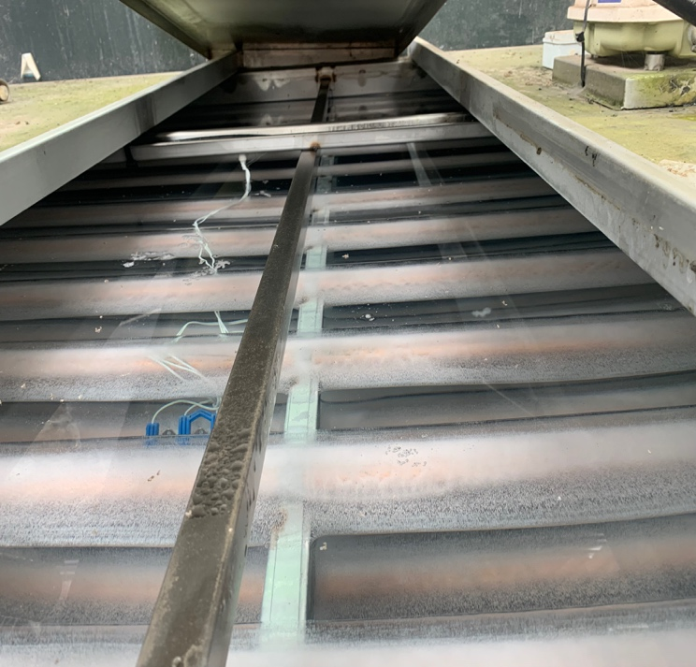
Heat exchanger. Ice bank.

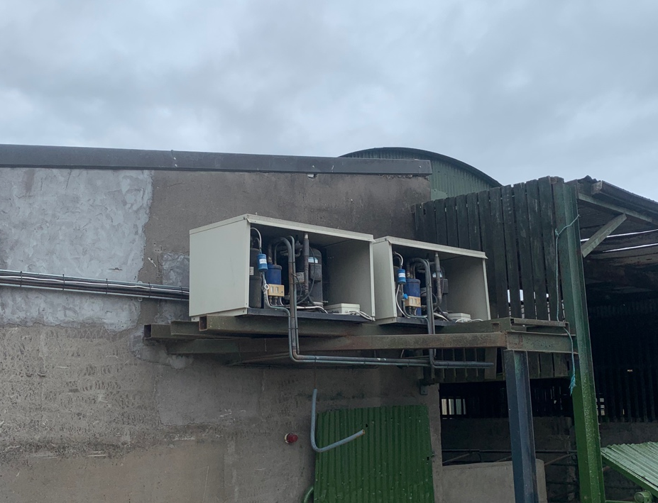
Compressors for ice bank.
The Ice Bank compressors can work together or independently depending on the available electricity produced.

The batteries, installed in 2021, can store 7.7KWh
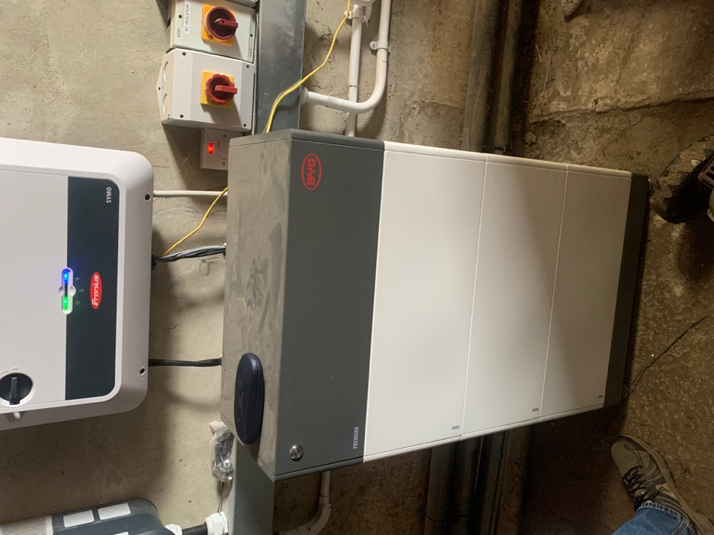
Battery storage
The batteries will charge until full and only then will electricity be diverted for export to the Grid. If the on farm electricity demand is higher than the PV production then the batteries will discharge to help before drawing from the Grid.

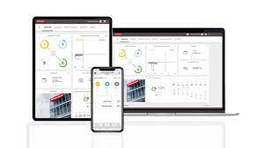

Gene uses an app called SolarWeb to monitor real time system performance and data recordig. This provides a wealth of data including power production, usage and export. It even keeps a record of the local weather conditions.

Day 2.

The next site I visited was David Foran’s farm. David milks a herd of 160 cows and is about 30 minutes outside of Waterford. David is a cousin of Pat from the first site and was impressed by the potential of system that he agreed to install a similar system for himself.
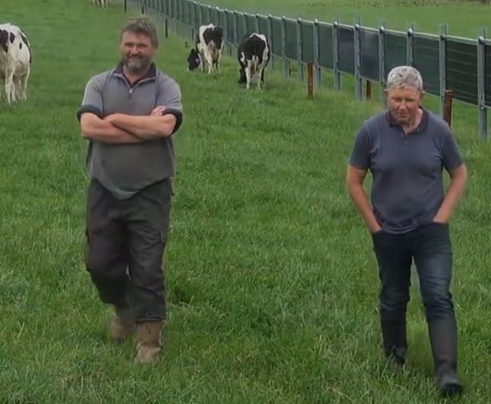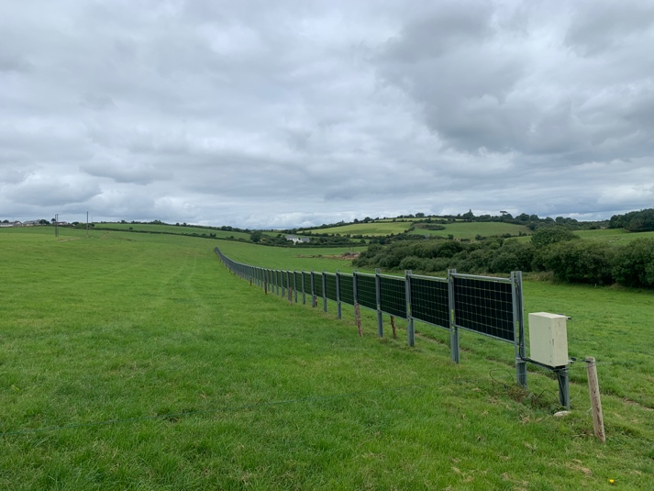
David Foran and Gene
The setup here is slightly different as they have used the panels to form a 150m boundary / fence to a turn out paddock next to the yard.

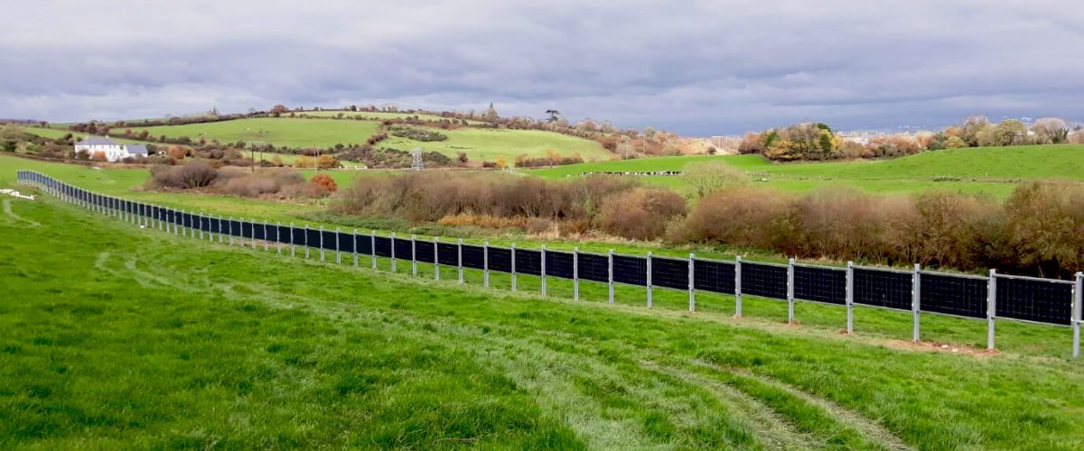

The system generated 27.5 MWh in 2020 which was half his total electricity consumption for the year. More importantly, 74% of the energy generated was consumed on the farm. This meant David is 37% self-sufficient for electricity usage.
The majority of unused electricity produced is diverted to a 500-litre hot water storage tank which is used for washing down after milking. The tank has 2 heating elements that can be switched on independently or together depending on how much spare electricity is being produced. The water in the tank is kept at 80°C.

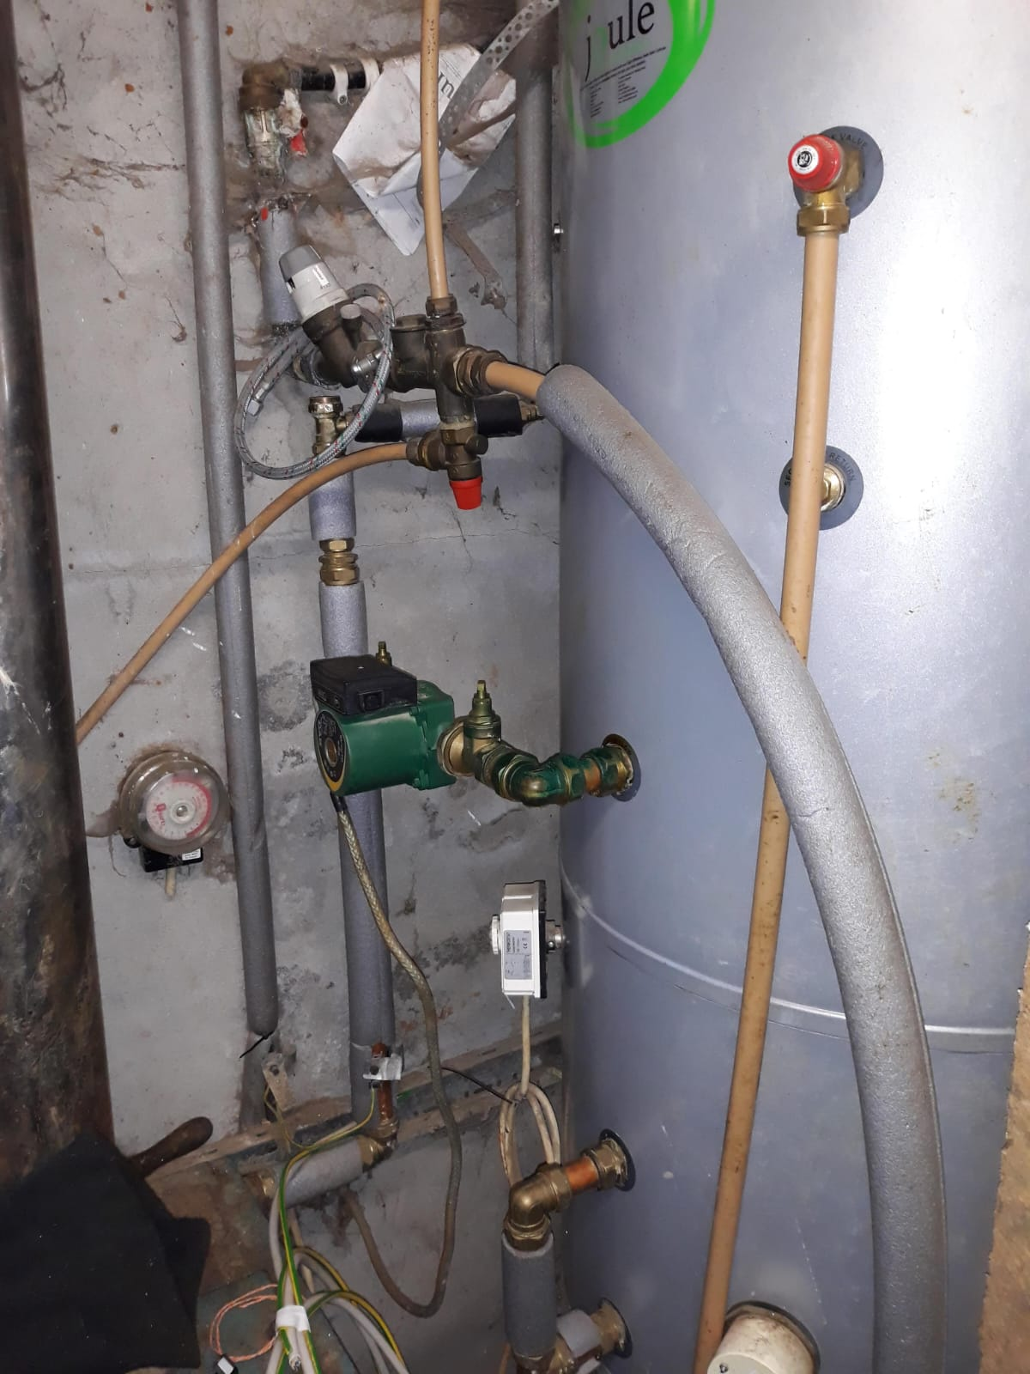

500 litre hot water tank.

David doesn’t currently have battery storage but it is something he plans to add soon to increase his self sufficiency.

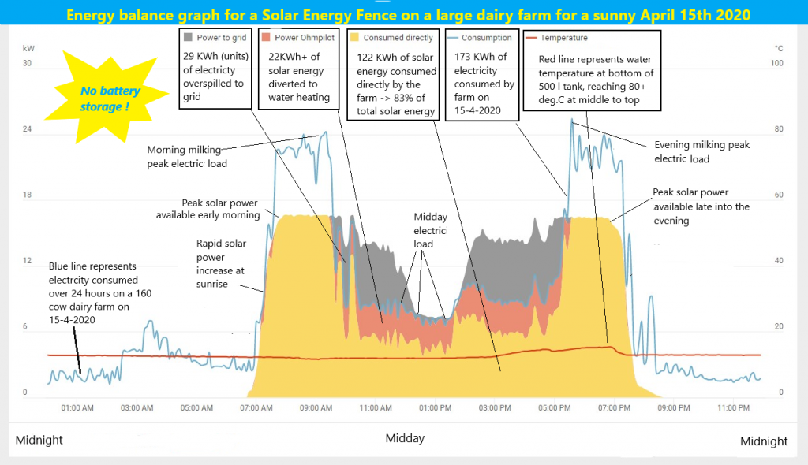

David is able use nearly ¾ of the energy he produces as his energy consumption tracks his energy usage very closely as shown in the graph above.
Costs

Both systems were of a similar size and design. The initial cost for the installation was approx. €48,000 ex VAT. At the time of installation there were capital expenditure grants of about 33%. Writing off 20% against income tax gives a NET cost of €25,000.

The estimated payback or the investment is about 4-5 years assuming 80-90% self-usage with an energy tariff of 25c per KWh and FIT (feed in tariff) of 14c per KWh. With the rising cost of energy, the payback time could be considerably less.

The installation costs were kept to a minimum as there were no additional works to be carried out to upgrade the grid connection at either site. The ground works for the support structure and cable runs were done by Pat and David themselves.

Problems with grid access and capacity can prove to be a major issue and make some installations prohibitively expensive.

Next Steps

As we aren’t a dairy farm, we wouldn’t benefit from the peak energy production in the morning and evening, however it may be of benefit to our planned diversification project, some further investigation into the energy requirements and estimated daily energy profiles is needed. An Energy Plan will form an integral part of our planning application.
I am currently in the process of comparing quotes and payback times for several different systems for use within our diversification project
It was obvious that to get the most out of any PV installation maximising self-usage is a must. Since returning from Ireland I have ordered a battery storage system for our roof mounted PV system which is scheduled to be installed in October.
I have also written to Julie James MS, minister for climate change, asking what the future holds for energy production in the agricultural sector. In response I was told that there are no plans at present to reintroduce the FIT (Feed in Tariff) system and the current Smart Export Guarantee (SEG) scheme should provide an adequate return and a good business case for PV investment considering the current high retail energy prices.
The visit has rekindled my interest in both PV and IT which has motivated me to relook at our energy usage and to implement new technologies within our business.
With the current energy crisis, I feel there will be huge opportunities to develop small scale om farm renewables in the future.

3 Key Messages to the industry

- Better Access to the Grid from DNO (Distribution Network Operators)

- Funding from government or energy suppliers is needed to assist in the cost of connecting to the Grid.

- Bifacial PV can spread the power production throughout the day better suiting grid demand as shown in the graph below.
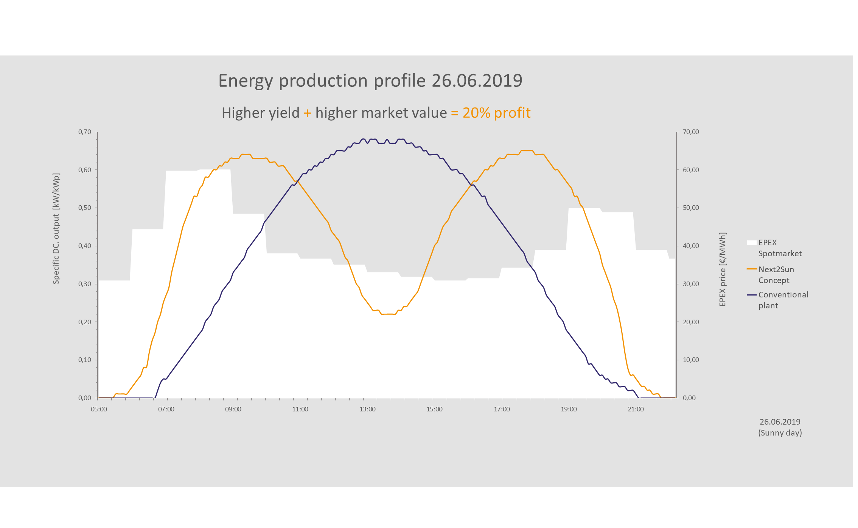
- Self-utilisation through different storage methods will increase the viability of installations.

- Bifacial PV has minimal loss of productive land allowing for both energy and food production from the same land.

- Given the high energy prices, the export price needs to reflect this increase.

